Sample instructions and worksheet for period 2:
Part Two Instructions and Worksheet
Safety Precautions
While experiments and lab activities are meant to be fun and educational, safety is the utmost important thing in lab. Today’s lab involves chemicals that are potential hazards and the following rules should be abided.
1. Always wear eye protection in lab.
2. Do not eat or drink any food or drinks (these include the chemicals you will handle)!
3. Never smell the chemicals directly. Rather, waft the air toward your face to get a sense of the scent of the chemical.
Also, today’s lab involves Hamilton syringes, which have sharp needles, for injecting your samples into the GC. Extra caution is required when handling these syringes so that you do not poke yourself or people around you.

Introduction
Last class, you used your smell and the GC to identify the two compounds present in a mixture. Today you will use the GC to quantify how much of each compound is present in the mixture. It is very likely that you were able to successfully identify the two compounds in the mixture yesterday by just smelling the mixture. Can you use smell to determine the percentage of each compound in a mixture?
Select Mixture B. Smell the mixture and hypothesize what the two compounds in that mixture are. Now hypothesize what the percentage of each compound is within that mixture. It’s important to remember that hypotheses do not have to be correct! You will use the GC today to determine the amount of each compound in the mixture.
To quantify the amount of a compound within a mixture using the GC, we must use calibration curves. A calibration curve is a linear equation (y = mx + b) that relates the peak area of a compound in the chromatogram to the amount of one of those compounds. The peak area of the compound of interest is standardized by comparing it to an internal standard. An internal standard is a known amount of a known compound that we add to the mixture in order to compare the internal standard’s peak area to our other compounds’ peak areas.
In our calibration curve, the peak area ratio of our compound (relative to the internal standard peak area) goes on the y-axis, and the percentage of the compound goes on the x-axis. A calibration curve must be constructed ahead of time by analyzing the chromatograms of mixtures with known ratios of their compounds. An example of the chromatograms used to construct a calibration curve is shown below. Note how, as the percentage of the compound increases, its peak area also increases. Graphing this forms a line. Using the equation of this line, we can determine the amount of that particular compound in an unknown mixture for any percentage of that compound. We have already prepared calibration curves for the mixture you will be using today (see your reference page).
Sample data used to construct a calibration curve. Each solution was individually made so that we already know what the percentage of the analyte in each mixture is:
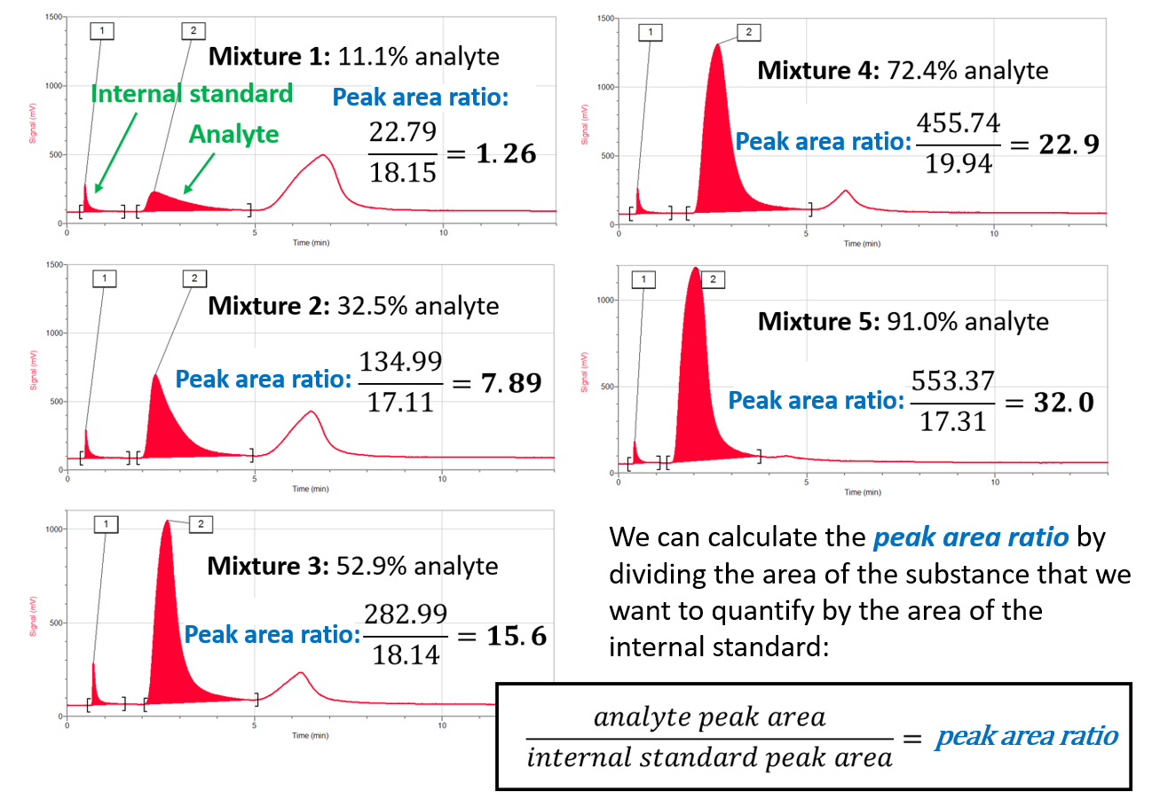
A calibration curve can then be made from comparing the peak area ratio of the analyte peak and the percentage of analyte in the mixture:
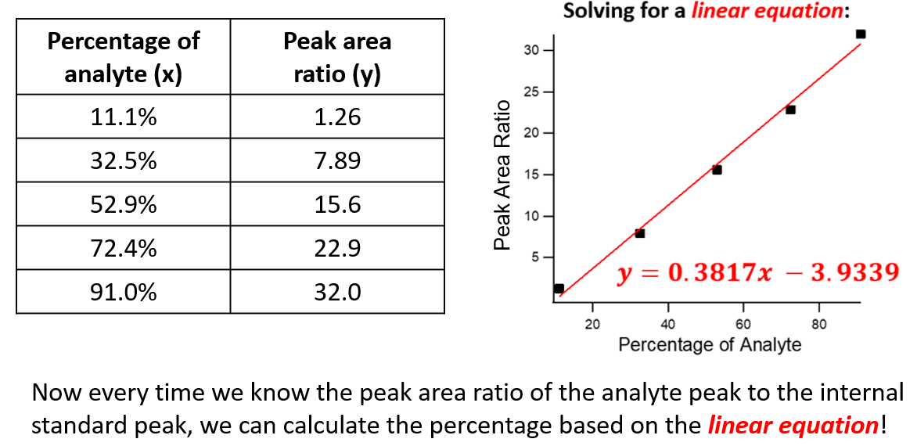
Pre-experiment observations
Obtain Mixture B. Based on its smell, what two compounds do you hypothesize to be in the mixture?
_______________________________________ and _______________________________________
Based on the smell of Mixture B, hypothesize what the percentage of each compound is in the mixture.
___________ % for the first compound, _________________________________________________
___________ % for the second compound, _______________________________________________
Do you expect your hypothesis to be accurate based on your qualitative observation using smell? Why or why not?
__________________________________________________________________________________
__________________________________________________________________________________
__________________________________________________________________________________
Have your instructor help you to add 150 µL ethyl acetate as an internal standard. Make sure to shake the mixture well after adding the ethyl acetate. How many peaks do you expect in the chromatogram?
__________________________________________________________________________________
Experimental procedure
- Write down your hypothesis for what two compounds are in Mixture B based on its scent. Also write down your hypothesis for the percentage of each compound in the mixture based on its scent. Do you think that this hypothesis will be accurate?
- Write down which GC (#1-#4) your group is using. The retention times and relative peak sizes vary slightly depending on the GC. Use the same GC as yesterday!
- Make sure the GC is plugged into a power source, connected to the computer, and turned on.
- Open the Logger Pro software.
- Press the green “Collect” button.
- Enter the following parameters and press “OK.” These parameters make up the experimental method:
Start Temperature = 65 °C
Hold Time = 1 minute
Ramp Rate = 3 °C/min
Final Temperature = 95 °C
Hold Time = 2 minutes
Total Time = 13 minutes
Pressure = 15.0 kPa
Sensitivity = Standard
- Wait for the GC to warm up. While warming up, the screen will display “DO NOT INJECT UNTIL GC IS READY.”
- Prepare your sample in the syringe by following the instructions detailed earlier. First, clean the syringe with acetone three times. Second, rinse the syringe with your sample mixture three times. Third, fill the syringe with 0.1 µL of your sample.
- When the GC says it is ready for injection, insert the needle of the syringe carefully into the injection port up to the brown needle guard. Follow the instructions detailed earlier to ensure the correct technique so that the needle doesn’t bend.
- With a partner, simultaneously inject the sample into the GC by pressing down the plunger and click “Collect.” You should start to see a red line being graphed across the screen from left to right.
- Immediately and quickly remove the needle from the injection port. Clean the syringe with acetone three times.

Background Information
While your experiment is running on the GC, answer the following questions about quantifying a substance in a mixture using gas chromatography. Feel free to discuss questions with your partner(s).
Give one real-world example of scientists using gas chromatography to quantify a substance:
__________________________________________________________________________________
In your own words, what is an internal standard?
__________________________________________________________________________________
__________________________________________________________________________________
__________________________________________________________________________________
What is the internal standard that we are using today?
__________________________________________________________________________________
Why do we need an internal standard to accurately quantify a substance in a mixture if we already know what its peak area is in the chromatogram?
__________________________________________________________________________________
__________________________________________________________________________________
__________________________________________________________________________________
Write the equation to calculate the peak area ratio of an analyte to the internal standard:
$$\frac{ }{ }=peak area ratio$$
A linear relationship has the equation of: $y=mx+b$. Match the variable to its meaning in a gas chromatography calibration curve:
- y a. percentage of analyte
- m (slope) b. relative response of analyte to internal standard
- x c. peak area ratio of the analyte peak to the internal standard peak
In your own words, how does one construct a calibration curve?
__________________________________________________________________________________
__________________________________________________________________________________
__________________________________________________________________________________

Data Analysis
- When the run has finished (after 13 minutes), look at the chromatogram on the computer. How many peaks are there? What does each peak represent? How many peaks did you expect? Click “Analyze” and select “Peak integration” as shown below.
- A dialog box should appear. Click and drag to highlight the first peak, like you did yesterday. Click the “Add” button. Repeat for the second peak in the chromatogram as well. You do not have to highlight the third peak.
- After adding each peak, the display will list the peaks and their retention times, peak area, and percentage that each peak contributes to the total area of all peaks chosen. In this particular experiment, we are concerned with the retention time and the peak area. Record both of these values for the first two peaks in your chromatogram.
Experimental data
Which GC is your group using? _______ Make sure to keep using this GC!
Record the peak number, retention time, and peak area in the table below. Using the reference table and your sense of smell, identify what two compounds are in Mixture B.
Peak Number | Retention Time | Peak Area | Chemical Compound
1
2
3

Was your hypothesis about the identity of the two compounds supported or not supported by the data?
__________________________________________________________________________________
__________________________________________________________________________________
Using the correct equation, calculate the peak area ratio of the second peak to the internal standard. What compound does this peak correspond to?
Compound: ________________________________________________
Relative response: $$\frac{ }{ }=$$

Now you have solved for one of the variables in the calibration curve. Which variable did you just solve for, considering that a basic linear equation is: $y=mx+b$?
__________________________________________________________________________________
Look on your reference table. What is the specific linear equation for the calibration curve for your GC?
__________________________________________________________________________________
Using a calculator, solve the linear equation corresponding to your GC’s calibration curve in the space below.

What does this number represent?
__________________________________________________________________________________
Using the value you just calculated, determine the percentage of the second compound in the mixture in the space below.

You are an analytical chemist in charge of measuring food quality for a surprisingly successful company that manufactures cough drops specifically for people allergic to bananas. You need to make sure that any mixture of fruity oils that go into the cough drops contain less than 10% of isoamyl acetate. Based on the experiment that you just ran, would you approve Mixture B for inclusion in the cough drop recipe? Why or why not?
__________________________________________________________________________________
__________________________________________________________________________________
__________________________________________________________________________________

