Sample instructions and worksheet for period 1:
Part One Instructions and Worksheet
Safety Precautions
While experiments and lab activities are meant to be fun and educational, safety is the utmost important thing in lab. Today’s lab involves chemicals that are potential hazards and the following rules should be abided:
1. Always wear eye protection in lab.
2. Do not eat or drink any food or drinks (these include the chemicals you will handle)!
3. Never smell the chemicals directly. Rather, waft the air toward your face to get a sense of the scent of the chemical.
Also, today’s lab involves Hamilton syringes, which have sharp needles, for injecting your samples into the GC. Extra caution is required when handling these syringes so that you do not poke yourself or people around you.

Introduction
Today we will be looking to separate two mixtures of chemical compounds that are naturally found in fruits. The three compounds that will be used are: isoamyl acetate, which is found in bananas; ethyl isovalerate, which is found in blueberries; and eucalyptol, which is found in many fruits. These chemical compounds and some of their properties are illustrated below:
As you can see, each compound is a colorless liquid, so they can’t be distinguished by sight. Smell each of the pure compounds by opening the vial and wafting the fumes towards your nose. Can you tell the compounds apart by scent?
There are two mixtures that you will analyze using the GC – one today and one tomorrow. Each mixture contains two of the compounds you smelled. As a group, you will try to determine what the compounds in Mixture A are. Smell the mixture just like you smelled the pure compounds. Can you tell what the two components in your mixture are by scent? Make a hypothesis as to what two components are in the mixture. You will test your hypothesis by using the GC!
How to use the gas chromatograph (GC) instrument
The GC must be connected to a power source and a computer with Logger Pro software installed. The GC can be connected to the computer using the USB adapter provided. The On/Off switch for the GC is located on the left side of the instrument.
As mentioned earlier, GC’s work by vaporizing a liquid sample into gases and flowing the gases through a column. In order to run the experiment properly, the sample must be introduced quickly and cleanly into the column. To do this, we will use a Hamilton syringe, which can inject small amounts of liquid into the GC. The Hamilton syringes we will use can hold a total volume of 1.0 µL (one microliter). There are 1000 microliters in a milliliter (mL)! Hamilton syringes are fragile and expensive, so be gentle and deliberate when using them! Here is how to properly use a Hamilton syringe:
- Make sure the syringe is clean by rinsing it first with acetone by repeating steps 2-5 three times.
- Press down the plunger fully to make sure there is no liquid in the syringe.
- Submerge the tip of the needle in the vial containing acetone.
- Carefully pull back the plunger about a third of the back (0.3 to 0.4 µL). Never pull back the plunger back more than 50% of the syringe’s total volume (0.5 µL).
- Remove the needle from the acetone and place the tip on a Kimwipe. Push down on the plunger carefully all the way to expel the acetone.
- Once the syringe is clean, rinse the syringe with your sample by repeating steps 7-9 three times. This is to remove any small amount of acetone that may still be in the syringe.
- Submerge the tip of the needle in the vial containing the sample mixture.
- Carefully pull back the plunger about a third of the back (0.3 to 0.4 µL). Never pull back the plunger back more than 50% of the syringe’s total volume (0.5 µL).
- Remove the needle from the sample mixture and place the tip on a Kimwipe. Push down on the plunger carefully all the way to expel the liquid.
- Now you are ready to prepare your sample for injection. Submerge the tip of the needle in the vial containing the sample mixture and carefully pull back the plunger to exactly 0.1 µL. The syringe should look like this:
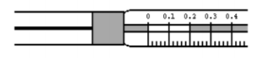
[Grab your reader’s attention with a great quote from the document or use this space to emphasize a key point. To place this text box anywhere on the page, just drag it.]
Samples need to be injected quickly and cleanly into the instrument through the injection port (on top) in order for the experiment to work well, so careful technique is necessary. The diagram below shows how the needle of the Hamilton syringe should be inserted into the injection port. It is very important to be careful while inserting the needle so that the needle doesn’t bend. Follow these instructions for inserting the needle:
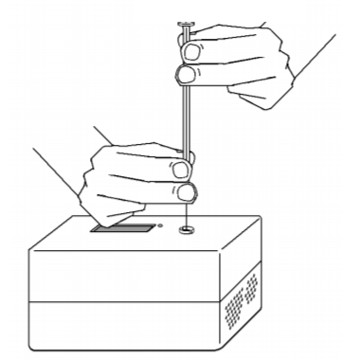
- Make sure the correct amount of sample is in the syringe.
- Hold the syringe in one hand and steady the needle with your other hand by grasping the brown needle guard.
- While continuing to hold the needle guard steady, carefully insert the needle as far as it can go into the injection port. Be careful to avoid bending the needle. If inserting the needle feels difficult, rotate the syringe slightly as you insert it. Do not push down on the plunger yet.

Since the time that each compound in the mixture takes to move through the column is important, we want to start data collection as soon as the sample is injected. We will do this by having one person inject the sample while another person starts the data collection on the computer at the same time. Detailed instructions on how to set up the program for data collection are discussed below in the “experimental procedure” section, but here is how you will inject the sample and collect data at the same time:
- Make sure the needle of the syringe is inserted as deeply as possible (up to the brown needle guard).
- Make sure that the program says that the “GC is ready.”
- Count to 3 with your partner. When you reach 3, have one person quickly press down the plunger of the syringe while the other person clicks “Collect” at the same time.
- Immediately remove the needle from the injection port.
- Clean the Hamilton syringe with acetone as the experiment runs, just like you did before you prepared your sample, then place it back where you found it.

Pre-experiment observations:
What does each pure compound smell like to you? Can you tell the difference between each compound based only on your sense of smell?
Isoamyl acetate: ___________________________________________________________________
Ethyl isovalerate: ___________________________________________________________________
Eucalyptol: _______________________________________________________________________
Obtain Mixture A. Carefully smell the mixture and form a hypothesis on the two compounds that are present in the mixture:
_______________________________________ and ______________________________________

Based on your hypothesis, how many peaks do you expect to see in the chromatogram? Why?
__________________________________________________________________________________
__________________________________________________________________________________
Based on your hypothesis, which compound in the mixture will the first peak correspond to? Why?
__________________________________________________________________________________
__________________________________________________________________________________
Based on your hypothesis, which compound in the mixture will the last peak correspond to? Why?
__________________________________________________________________________________
__________________________________________________________________________________

Experimental Procedure
- Write down your hypothesis for what two compounds are in Mixture A based on its scent.
- Write down which GC (#1-#4) your group is using. The retention times and relative peak sizes vary slightly depending on the GC.
- Make sure the GC is plugged into a power source, connected to the computer, and turned on.
- Open the Logger Pro software.
- Press the green “Collect” button.
- Enter the following parameters and press “OK.” These parameters make up the experimental method:
Start Temperature = 65 °C
Hold Time = 1 minute
Ramp Rate = 3 °C/min
Final Temperature = 95 °C
Hold Time = 2 minutes
Total Time = 13 minutes
Pressure = 15.0 kPa
Sensitivity = Standard
- Wait for the GC to warm up. While warming up, the screen will display “DO NOT INJECT UNTIL GC IS READY.”
- Prepare your sample in the syringe by following the instructions detailed earlier. First, clean the syringe with acetone three times. Second, rinse the syringe with your sample mixture three times. Third, fill the syringe with 0.1 µL of your sample.
- When the GC says it is ready for injection, insert the needle of the syringe carefully into the injection port up to the brown needle guard. Follow the instructions detailed earlier to ensure the correct technique so that the needle doesn’t bend.
- With a partner, simultaneously inject the sample into the GC by pressing down the plunger and click “Collect.” You should start to see a red line being graphed across the screen from left to right.
- Immediately and quickly remove the needle from the injection port. Clean the syringe with acetone three times.

Background Information
While your experiment is running, answer the following questions about separating mixtures using gas chromatography. Feel free to discuss questions with your partners and the instructors.
What is one reason that a chemist might want to use chromatography?
____________________________________________________________________________________________________________________________________________________________________
__________________________________________________________________________________
In gas chromatography, what is the mobile phase?
__________________________________________________________________________________
In gas chromatography, what is the stationary phase?
__________________________________________________________________________________
In today’s experiment, what is the analyte?
__________________________________________________________________________________
What chemical properties of a compound are used in chromatography to help separate it from the rest of a mixture?
__________________________________________________________________________________
What physical property of a compound is used in gas chromatography to further help separate it from the rest of a mixture?
__________________________________________________________________________________
In this particular experiment, the compounds with higher boiling points have longer retention times because they enter the column later than low-boiling compounds and interact with the column more. With this in mind, look at the table of fruity compounds on your reference page. Which compound do you expect to have the longest retention time?
__________________________________________________________________________________
What is the maximum volume that today’s Hamilton syringe can hold? What is the maximum volume to which you should pull up the plunger? What is the injection volume we will use today?
__________________________________________________________________________________
__________________________________________________________________________________

Data Analysis
- When the run has finished (after 13 minutes), look at the chromatogram on the computer. How many peaks are there? What does each peak represent? How many peaks did you expect? Click “Analyze” and select “Peak integration” as shown below.
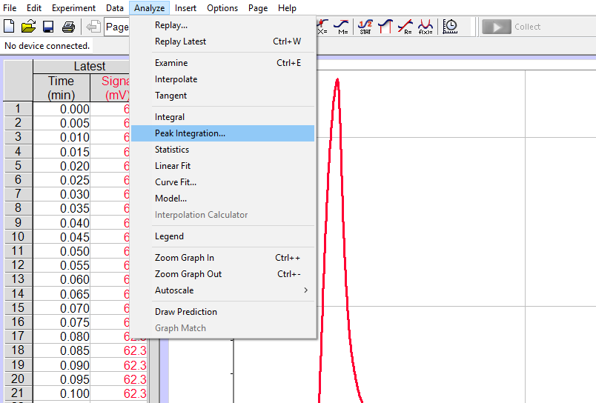
- A dialog box should appear. Click and drag to highlight the first peak, as depicted below. Click the “Add” button. Repeat for each peak in the chromatogram.
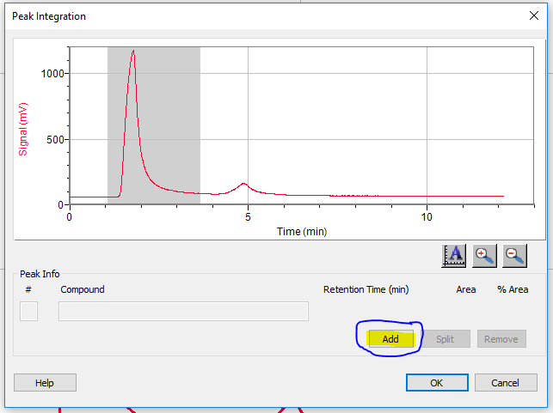
- After adding each peak, the display will list the peaks and their retention times, peak area, and percentage that each peak contributes to the total area of all peaks chosen. An example is shown below. In this particular experiment, we are only concerned with the retention time. Record the retention time for each peak in your chromatogram.
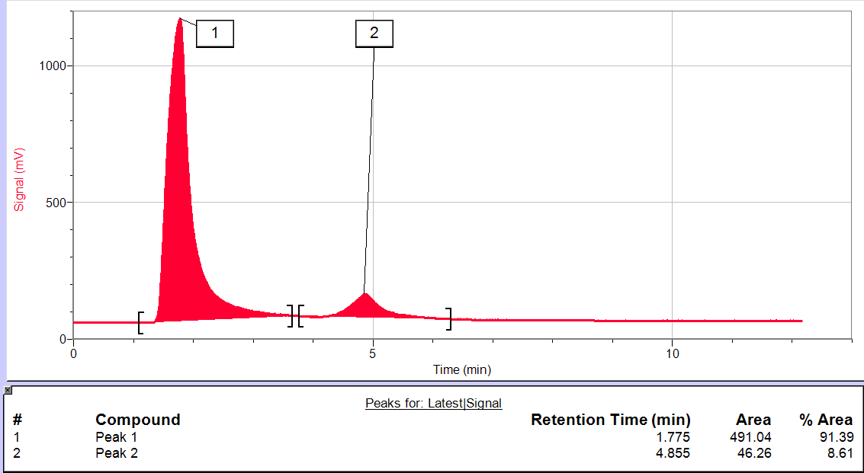

Experimental Data
Which GC is your group using? _______ Make sure to keep using this GC!
Record the peak number, retention time, and peak area in the table below. Using the reference table and your sense of smell, identify what two compounds are in Mixture A.
Peak Number | Retention Time | Peak Area | Chemical Compound
1
2
3

Based on the retention times of your peaks, was your hypothesis supported or not supported by the experimental data? Why?
______________________________________________________________________________________________________________________________________________________________________________________________________________________________________________________
Look at your reference page and compare isoamyl acetate and ethyl isovalerate, which are isomers. Why do you think they have very similar retention times?
__________________________________________________________________________________
__________________________________________________________________________________
__________________________________________________________________________________
Imagine that you had a mixture containing both isoamyl acetate and ethyl isovalerate. How easy do you think it is to separate the two compounds? What might a chromatogram of this mixture look like?
__________________________________________________________________________________
__________________________________________________________________________________
__________________________________________________________________________________

